

**T E A C H I N G**

**P R O F E S S I O N**

**A S A**

**Mrs. Love**



**Description:** The Examining the Teaching Profession is the foundational course under the Teaching as a Profession pathway and prepares students for future positions in the field of education. Teaching as a Profession students study, apply, and practice the use of current technologies, effective teaching and learning strategies, the creation of an effective learning environment, the creation of instructional opportunities for diverse learners and students with special needs, and plan instruction based on knowledge of subject matter, students, community, and curriculum performance standards.

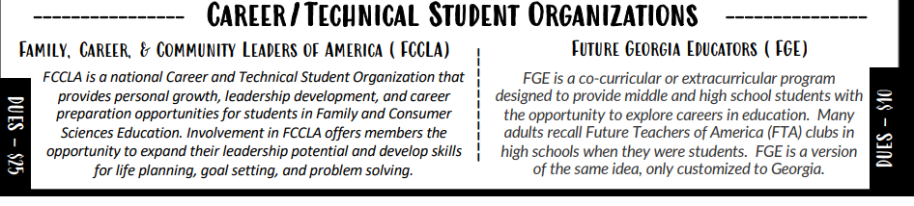

Unit 1: CTSO

Unit 2: Ethics in Education

Unit 3: Career Paths

Unit 4: Professional Disposition

Unit 5: History of Education

Unit 6: Effective Learning Environments

Unit 7: Instruction and Assessment

Unit 8: Learning Differences

Unit 9: Parent and Community Involvement

Unit 10: Technology in Classrooms

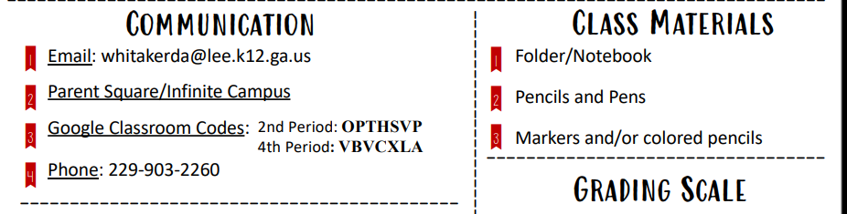

Email: adkinsta1@richmond.k12.ga.us

Class Website: https://sites.google.com/view/tapghhs/home

Phone: (706) 796-4924

Office Hours: (Room 115) Mondays & Tuesdays 2:30 pm - 3:30 pm



Class Notebook/ Laptop

Pens/Pencils

Colored Pencils/ Highlighters

Index Cards





1st Offense – Verbal Warning

2nd Offense – After School Detention

3rd Offense – Parent Contact

4th Offense – Office Referral







Arrive to class on time, prepared, and ready to learn

Submit your best work in a timely manner

Be courteous, kind, and respectful

Challenge yourself to continuously improve

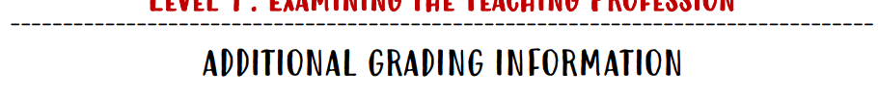

**Major: 40% Minor: 60%**

A- 90-100

B- 80-89

C- 75-79

D- 74-70

F- Below 70

NC- No Credit

**LATE WORK WILL BE ACCEPTED FOR UP TO 2 WEEKS AFTER THE DUE DATE FOR PARTIAL CREDIT**

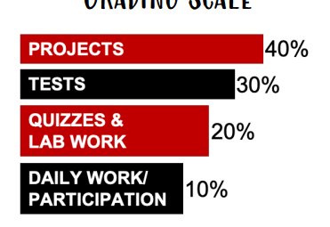

**(Major)**

**(Major)**

**(Minor)**

**(Minor)**



Additional time is granted for work completion to students who are absent. Students have five (5) school days in which to complete and turn in any missed work.



This pathway is intended for students who are interested in careers in the Education field. Students are expected to uphold a professional standard as a future educator. This includes participating in professional dress days, confidentiality agreements, applications, case studies, being well prepared for class daily and being actively engaged during class. Attendance and behavior must also remain consistent and professional. Failure to do so could result in dismissal from this pathway.

**NEW POLICY:** No cell phone use will be permitted inside of the school or classroom.

**Examining the Teaching Profession Syllabus Student & Parent Acknowledgement**

I have read and understood the syllabus in its entirety. I have asked questions about anything for which I want clarification.

Student’s Name: ___________________________________

Student’s Signature: ________________________________

Guardian’s Signature: _______________________________

Guardian’s email address: ___________________________

Please circle your preferred method of contact: email phone call note

*\*I make every effort to respond to email within 24 hours, please follow up with a phone call to the school if you do not hear from me.\**

Please list any additional information you would like me to know about your student so that he/she may have the best possible year. ____________________________________________________________________________________________________________________________________________________________________________________________________________________________________________________________________________________

